Department of Computer Science and Engineering

DESIGN AND ANALYSIS OF ALGORITHMS LAB (7G147)
Lab Manual
II B.Tech II Sem



Annamacharya Institute of Technology and Sciences

New Boyanapalli, Rajampet,YSR Kadapa District – 516 126 (A. P.)

ANNAMACHARYA INSTITUTE OF TECHNOLOGY & SCIENCES::RAJAMPET
(Autonomous)

VISION

We impart futuristic technical education and instill high patterns of discipline through our dedicated staff who set global standards, making our students technologically superior and ethically strong, who in turn shall improve the quality of life of the human race.
MISSION

Our mission is to educate students from the local and rural areas and from other states so that they become enlightened individuals, improving the living standards of their families, industry and society. We provide individual attention, world-class quality of Technical education and take care of character building.

ANNAMACHARYA INSTITUTE OF TECHNOLOGY & SCIENCES::RAJAMPET
(Autonomous)
DEPARTMENT OF COMPUTER SCIENCE & ENGINEERING

VISION

To become an advanced learning centre in the field of Computer Science and Engineering that make knowledgeable, skilful, socially responsible and ethical professionals.
MISSION

To provide matured engineering graduates, who can serve nation and solve real world problems, with strong moral and professional convictions and interdisciplinary research capabilities.

ANNAMACHARYA INSTITUTE OF TECHNOLOGY & SCIENCES::RAJAMPET
(AN AUTONOMOUS INSTITUTION)
II B. Tech II Semester

DESIGN AND ANALYSIS OF ALGORITHMS LAB (7G147)
Course Objectives:
Upon completion of this course, students will be able to do the following:
- Analyze the asymptotic performance of algorithms.
- Write rigorous correctness proofs for algorithms.
- Demonstrate a familiarity with major algorithms and data structures.
- Apply important algorithmic design paradigms and methods of analysis.
- Synthesize efficient algorithms in common engineering design situations.
Course Outcomes:
Students who complete the course will have demonstrated the ability to do the following:
- Analyze worst-case running times of algorithms using asymptotic analysis.
- Describe the divide-and-conquer paradigm and explain when an algorithmic design situation calls for it. Synthesize divide-and-conquer algorithms. Derive and solve recurrences describing the performance of divide-and-conquer algorithms.
- Trace the greedy paradigm and explain when an algorithmic design situation calls for it. Synthesize greedy algorithms, and analyze them
- Outline the dynamic-programming paradigm and explain when an algorithmic design situation calls for it. Synthesize dynamic-programming algorithms, and analyze them.
5. Narrate the back tracking and Branch and Bound paradigm and explain when an algorithmic design situation calls for it.
Program 1: Sort a given set of elements using the Quicksort method and determine the time required to sort the elements. Repeat the experiment for different values of n, the number of elements in the list to be sorted and plot a graph of the time taken versus n.
Program 2: Implement a parallelized Merge Sort algorithm to sort a given set of elements and determine the time required to sort the elements. Repeat the experiment for different values of n, the number of elements in the list to be sorted and plot a graph of the time taken versus n.
Program 3: Find Minimum Cost Spanning Tree of a given undirected graph Prim’s algorithm.
Program 4: Find Minimum Cost Spanning Tree of a given undirected graph using Kruskal's algorithm.
Program 5: Implement the 0/1 knapsack problem by the following.
a) Greedy algorithm. b) Dynamic programming algorithm
Program 6: Find optimal ordering of matrix chain multiplication using Dynamic programming method.
Program 7: Implement dynamic programming algorithm to solve all pairs shortest path problem.
Program 8: Uses dynamic programming algorithm to solve the optimal binary search tree problem.
Program 9: Consider the problem of eight queens on an (8x8) chessboard. Two queens are said to attack each other if they are on the same row, column, or diagonal. Implements backtracking algorithm to solve the problem i.e. place eight non-attacking queens on the board.
Program 10: Implement the 0/1 knapsack problem using the Branch and bound algorithm.
Program 11: Implement the traveling sales person’s problem using the Branch and Bound.
Text Books:
- Richard F.Gilberg, BehrouzA.Forouzan, Thomson, “Data Structures, A Pseudocode Approach with C++”, 1st ed., Business Information Press, 2007.
- D.S.Malik, Thomson, “Data Structures Using C++”, 1st ed., Cengage Learning, 2007.
- Ellis Horowitz, SatrajSahni and Rajasekharam, “Fundamentals of Computer Algorithms”, 2nd ed., Galgotia publications pvt. Ltd, 2006.
Mode of evaluation:
Day to Day Evaluation | Internal lab Evaluation | Semester End lab Examination (SEE)  70 Marks
20 Marks | 10 Marks | Semester End lab Examination (SEE)  70 Marks

IDEX
S.No . | Experiment | Page No
1. | QUICK SORT | 9
2. | MERGE SORT | 13
3. | MINIMUM COST SPANNING TREE USING PRIM’S ALGORITHM | 16
4. | MINIMUM COST SPANNING TREE USING KRUSKAL’S ALGORITHM | 19
5. | KNAPSACK PROBLEM USING :  A) GREEDY METHOD B)DYNAMIC PROGRAMMING | 22
6. | MATRIX CHAIN MULTIPLICATION | 27
7. | ALL PAIRS SHORTEST PATH PROBLEM | 32
8. | OPTIMAL BINARY SEARCH TREE | 36
9. | N QUEENS PROBLEM | 40
10. | 0/1 KNAPSACK PROBLEM USING BRANCH AND BOUND ALGORITHM | 43
11. | TRAVELLING SALES PERSON PROBLEM USING BRANCH AND BOUND ALGORITHM | 48

QUICK SORT

1.1 OBJECTIVE:
Sort a given set of elements using the Quick sort method and determine the time required to sort the elements. Repeat the experiment for different values of n, the number of elements in the list to be sorted and plot a graph of the time taken versus n. The elements can be read from a file or can be generated using the random number generator.
1.2 RESOURCES:
Dev C++
1.3 PROGRAM LOGIC:
QuickSort is a Divide and Conquer algorithm. It picks an element as pivot and partitions the given array around the picked pivot.
There are many different versions of QuickSort that pick pivot in different ways.
1. Always pick first element as pivot.
2. Always pick last element as pivot (implemented below)
3. Pick a random element as pivot.
4. Pick median as pivot.
The key process in QuickSort is partition. Target of partitions is, given an array and an element p of array as pivot, put p at its correct position in sorted array and put all smaller elements (smaller than p) before p, and put all greater elements (greater than p) after p.
1.4 PROCEDURE:
1. Create: Open Dev C++, write a program after that save the program with .c extension.
2. Compile: F9
3. Execute: F10
1.5 SOURCE CODE:
include <stdio.h>
include <time.h>
voidExch(int *p, int *q)
{
int temp = *p; *p = *q; *q = temp;
}
voidQuickSort(int a[], int low, int high)
{
int i, j, key, k;
if(low>=high)
return;
key=low;
i=low+1;
j=high;
while(i<=j)
{
while ( a[i] <= a[key] )
i=i+1;
while ( a[j] > a[key] )
j=j -1;
if(i<j)
Exch(&a[i], &a[j]);
}
Exch(&a[j], &a[key]);
QuickSort(a, low, j-1);
QuickSort(a, j+1, high);
}
void main()
{
int n, a[1000],k;
clock_tst,et; double ts; clrscr();
printf("\n Enter How many Numbers: ");
scanf("%d", &n);
printf("\nThe Random Numbers are:\n");
for(k=1; k<=n; k++)
{
a[k]=rand();
printf("%d\t",a[k]);
}
st=clock();
QuickSort(a, 1, n);
et=clock();
ts=(double)(et-st)/CLOCKS _PER_SEC;
printf("\nSorted Numbers are: \n ");
for(k=1; k<=n; k++)
printf("%d\t", a[k]);
printf("\nThe time taken is %e",ts);
}
1.6 INPUT/ OUTPUT

1.7 LAB VIVA QUESTIONS:

1. What is the average case time complexity of quick sort.
2. Explain is divide and conquer.
3. Define in place sorting algorithm.
4. List different ways of selecting pivot element.

MERGE SORT
1.1 OBJECTIVE:
Implement merge sort algorithm to sort a given set of elements and determine the time required to sort the elements. Repeat the experiment for different values of n, the number of elements in the list to be sorted and plot a graph of the time taken versus n. The elements can be read from a file or can be generated using the random number generator.
1.2 RESOURCES:
Dev C++
1.3 PROGRAM LOGIC:
Merge Sort is a Divide and Conquer algorithm. It divides input array in two halves, calls itself for the two halves and then merges the two sorted halves.
The merge() function is used for merging two halves. The merge(a, low, mid, high) is key process that assumes that a[low..mid] and a[mid+1..high] are sorted and merges the two sorted sub-arrays into one.
1.4 PROCEDURE:
1. Create: Open Dev C++, write a program after that save the program with .c extension.
2. Compile:F9
3. Execute: F10
1.5 SOURCE CODE:
#include <stdio.h>
#include<time.h>
int b[50000];
void Merge(int a[], int low, int mid, int high)
{
int i, j, k;
i=low; j=mid+1; k=low;
while ( i<=mid && j<=high )
{
if( a[i] <= a[j] )
b[k++] = a[i++] ;
else
b[k++] = a[j++] ;
}
while (i<=mid)
b[k++] = a[i++] ;
while (j<=high)
b[k++] = a[j++] ;
for(k=low; k<=high; k++)
a[k] = b[k];
}
voidMergeSort(int a[], int low, int high)
{
int mid;
if(low >= high)
return;
mid = (low+high)/2 ;
MergeSort(a, low, mid);
MergeSort(a, mid+1, high);
Merge(a, low, mid, high);
}
void main()
{
int n, a[50000],k;
clock_tst,et;
doublets;
printf("\n Enter How many Numbers:");
scanf("%d", &n);
printf("\nThe Random Numbers are:\n");
for(k=1; k<=n; k++)
{
a[k]=rand();
printf("%d\t", a[k]);
}
st=clock();
MergeSort(a, 1, n);
et=clock();
ts=(double)(et-st)/CLOCKS_PER_SEC;
printf("\n Sorted Numbers are : \n ");
for(k=1; k<=n; k++)
printf("%d\t", a[k]);
printf("\nThe time taken is %e",ts);
}
2.6 INPUT/ OUTPUT
2.7 LAB VIVA QUESTIONS:
1. What is the running time of merge sort?
2. What technique is used to sort elements in merge sort?
3. Is merge sort in place sorting algorithm?
4. Define stable sort algorithm.

MINIMUM COST SPANNING TREE
3.1 OBJECTIVE:
Find Minimum Cost Spanning Tree of a given undirected graph using Prim’s algorithm.
3.2 RESOURCES:
Dev C++
3.3 PROGRAM LOGIC:
1) Create a set Sthat keeps track of vertices already included in MST. 2) Assign a key value to all vertices in the input graph. Initialize all key values as INFINITE. Assign key value as 0 for the first vertex so that it is picked first. 3) While S doesn’t include all vertices.
a) Pick a vertex u which is not there in Sand has minimum key value. b) Include u to S.
c) Update key value of all adjacent vertices of u.
To update the key values, iterate through all adjacent vertices. For every adjacent vertex v, if weight of edge u-v is less than the previous key value of v, update the key value as weight of u-v
The idea of using key values is to pick the minimum weight edge from cut. The key values are used only for vertices which are not yet included in MST, the key value for these vertices indicate the minimum weight edges connecting them to the set of vertices included in MST.
3.4 PROCEDURE:
1. Create: Open Dev C++, write a program after that save the program with .c extension.
2. Compile: F9
3. Execute: F10
3.5 SOURCE CODE.
#include<stdio.h>
int a,b,u,v,n,i,j,ne=1;
int visited[10]={0},min,mincost=0,cost[10][10];
void main() {
printf("\n Enter the number of nodes:"); scanf("%d",&n);
printf("\n Enter the adjacency matrix:\n"); for(i=1;i<=n;i++)
for(j=1;j<=n;j++) {
scanf("%d",&cost[i][j]);
if(cost[i][j]==0)
cost[i][j]=999;
}
visited[1]=1;
printf("\n");
while(ne<n) {
for(i=1,min=999;i<=n;i++)
for(j=1;j<=n;j++)
if(cost[i][j]<min)
if(visited[i]!=0) {
min=cost[i][j];
a=u=i; b=v=j;
}
if(visited[u]==0 || visited[v]==0) {
printf("\n Edge %d:(%d %d) cost:%d",ne++,a,b,min); mincost+=min;
visited[b]=1;
}
cost[a][b]=cost[b][a]=999;
}
printf("\n Minimun cost=%d",mincost);
}
3.6 INPUT/ OUTPUT
3.7 LAB VIVA QUESTIONS:
1. What is Minimum Cost spanning Tree.
2. Explain Prim’s ALGORITHM.
3. What is time complexity of Prim’s algorithm.

MINIMUM COST SPANNING TREE
4.1 OBJECTIVE:
Find Minimum Cost Spanning Tree of a given undirected graph using Kruskal’s algorithm.
4.2 RESOURCES:
Dev C++
4.3 PROGRAM LOGIC:
1. Sort all the edges in non-decreasing order of their weight.
2. Pick the smallest edge. Check if it forms a cycle with the spanning tree formed so far. If cycle is not formed, include this edge. Else, discard it.
3. Repeat step#2 until there are (V-1) edges in the spanning tree.
4.4 PROCEDURE:
1. Create: Open Dev C++, write a program after that save the program with .c extension.
2. Compile: F9
3. Execute: F10
4.5 SOURCE CODE:
#include<stdio.h>
#include<stdlib.h>
int i,j,k,a,b,u,v,n,ne=1;
intmin,mincost=0,cost[9][9],parent[9];
int find(int);
intuni(int,int);
void main()
{
printf("\n Implementation of Kruskal's algorithm\n\n");
printf("\nEnter the no. of vertices\n");
scanf("%d",&n);
printf("\nEnter the cost adjacency matrix\n");
for(i=1;i<=n;i++) {
for(j=1;j<=n;j++) {
scanf("%d",&cost[i][j]);
if(cost[i][j]==0)
cost[i][j]=999;
}
}
printf("\nThe edges of Minimum Cost Spanning Tree are\n\n");
while(ne<n) {
for(i=1,min=999;i<=n;i++) {
for(j=1;j<=n;j++) {
if(cost[i][j]<min) {
min=cost[i][j];
a=u=i;
b=v=j;
}
}
}
u=find(u);
v=find(v);
if(uni(u,v)) {
printf("\n%d edge (%d,%d) =%d\n",ne++,a,b,min);
mincost +=min;
}
cost[a][b]=cost[b][a]=999;
}
printf("\n\tMinimum cost = %d\n",mincost);
}
int find(int i) {
while(parent[i])
i=parent[i];
return i;
}
int uni(int i,int j) {
if(i!=j) {
parent[j]=i;
return 1;
}
return 0;
}
4.6 INPUT/ OUTPUT
4.7 LAB VIVA QUESTIONS:
1. What is the time complexity of Kruskal’s algorithm.
2. Define spanning tree.
3. Define minimum cost spanning tree.

KNAPSACK PROBLEM
5.1 OBJECTIVE:
Implement Knapsack problem using Greedy Method and Dynamic Programming.
5.2 RESOURCES:
Dev C++
5.3 PROGRAM LOGIC:
Using Greedy Method:
Given some items, pack the knapsack to get the maximum total profit. Each item has some
Weight and some profit. Total weight that we can carry is no more than knapsack capacity W. When object place into knapsack 1<= x_{i} <0 otherwise x_{i}=0, 1<= i <=n.
Using Dynamic Programing:
Given n objecs, pack the knapsack to get the maximum total profit. Each item has some
Weight and some profit. Total weight that we can carry is no more than knapsack capacity W. When object place into knapsack x_{i}=1 otherwise x_{i}=0.
5.4 PROCEDURE:
1. Create: Open Dev C++, write a program after that save the program with .c extension.
2. Compile: F9
3. Execute: F10
5.5 SOURCE CODE:
Using Greedy Method:
# include<stdio.h>
void knapsack(int n, float weight[], float profit[], float capacity) {
float x[20], tp = 0;
int i, j, u;
u = capacity;

for (i = 0; i < n; i++)
x[i] = 0.0;

for (i = 0; i < n; i++) {
if (weight[i] > u)
break;
else {
x[i] = 1.0;
tp = tp + profit[i];
u = u - weight[i];
}
}
if (i < n)
x[i] = u / weight[i];

tp = tp + (x[i] * profit[i]);

printf("\nThe result vector is:- ");
for (i = 0; i < n; i++)
printf("%f\t", x[i]);

printf("\nMaximum profit is:- %f", tp);
}
int main() {
float weight[20], profit[20], capacity;
int num, i, j;
float ratio[20], temp;
printf("\nEnter the no. of objects:- ");
scanf("%d", &num);

printf("\nEnter the wts and profits of each object:- ");
for (i = 0; i < num; i++) {
scanf("%f %f", &weight[i], &profit[i]);
}
printf("\nEnter the capacityacity of knapsack:- ");
scanf("%f", &capacity);

for (i = 0; i < num; i++) {
ratio[i] = profit[i] / weight[i];
}
for (i = 0; i < num; i++) {
for (j = i + 1; j < num; j++) {
if (ratio[i] < ratio[j]) {
temp = ratio[j];
ratio[j] = ratio[i];
ratio[i] = temp;
temp = weight[j];
weight[j] = weight[i];
weight[i] = temp;
temp = profit[j];
profit[j] = profit[i];
profit[i] = temp;
}
}
}
knapsack(num, weight, profit, capacity);
return(0);
}
Using Dynamic Programming:
#include<stdio.h>
int w[10],p[10],v[10][10],n,i,j,cap,x[10]={0};
int max(inti,int j) {
return ((i>j)?i:j);
}
int knap(inti,int j) {
int value;
if(v[i][j]<0) {
if(j<w[i])
value=knap(i-1,j);
else
value=max(knap(i-1,j),p[i]+knap(i-1,j-w[i]));
v[i][j]=value;
}
return(v[i][j]);
}
int main() {
int profit,count=0;
printf("\nEnter the number of objects ");
scanf("%d",&n);
printf("Enter the profit and weights of the elements \n ");
for(i=1;i<=n;i++) {
printf("\nEnter profit and weight For object no %d :",i);
scanf("%d%d",&p[i],&w[i]);
}
printf("\nEnter the capacity ");
scanf("%d",&cap);
for(i=0;i<=n;i++)
for(j=0;j<=cap;j++)
if((i==0)||(j==0))
v[i][j]=0;
else
v[i][j]=-1;
profit=knap(n,cap);
i=n; j=cap;
while(j!=0&&i!=0) {
if(v[i][j]!=v[i-1][j]) {
x[i]=1;
j=j-w[i]; i--;
}
else
i--;
}
printf("object included are \n ");
printf("Sl.no\tweight\tprofit\n");
for(i=1;i<=n;i++)
if(x[i])
printf("%d\t%d\t%d\n",++count,w[i],p[i]);
printf("Total profit = %d\n",profit);
}
5.6 INPUT/ OUTPUT
5.7 LAB VIVA QUESTIONS:
1. Define knapsack problem.
2. Define principle of optimality.
3. What is the optimal solution for knapsack problem?
4. What is the time complexity of knapsack problem?

MATRIX CHAIN MULTIPLICATION
6.1 OBJECTIVE:
Given a sequence of matrices, find the most efficient way to multiply these matrices together. The problem is not actually to perform the multiplications, but merely to decide in which order to perform the multiplications.
6.2 RESOURCES:
Dev C++
6.3 PROGRAM LOGIC:
1. Let we have “n” number of matrices A1, A2, A3 ……… An and dimensions are d0 x d1, d1 x d2, d2 x d3 …………. d_{n-1} x d_{n} (i.e Dimension of Matrix A_{i} is d_{i-1} x d_{i}
Solving a chain of matrix that, A_{i} A_{i+1} A_{i+2} A_{i+3} ……. A_{j} = (A_{i} A_{i+1} A_{i+2} A_{i+3} ……. A_{k} ) (A_{k+1} A_{k+2} ……. A_{j} ) + d_{i-1} d_{k} d_{j} where i <= k < j.
2.Here total i to j matrices, Matrix i to k and Matrix k+1 to j should be solved in recursive way and finally these two matrices multiplied and these dimensions d_{i-1} d_{k} d_{j} (number of multiplications needed) added. The variable k is changed i to j.
Recursive function is:
M [ i , j ] = { 0 ; when i=j ; [means it is a single matrix . If there is only one matrix no need to multiply with any other. So 0 (zero) multiplications required.]
= { min { M[ i, k ] + M[k+1, j ] + d_{i-1} d_{k} d_{j} } where i <= k< j.
6.4 PROCEDURE:
1. Create: Open Dev C++, write a program after that save the program with .c extension.
2. Compile: F9
3. Execute: F10
6.5 SOURCE CODE:
#include <stdio.h>
#include<limits.h>
#define INFY 999999999
long int m[20][20];
int s[20][20];
int p[20],i,j,n;
void print_optimal(int i,int j)
{
if (i == j)
printf(" A%d ",i);
else
{
printf("( ");
print_optimal(i, s[i][j]);
print_optimal(s[i][j] + 1, j);
printf(" )");
}
}
void matmultiply(void)
{
long int q;
int k;
for(i=n;i>0;i--)
{
for(j=i;j<=n;j++)
{
if(i==j)
m[i][j]=0;
else
{
for(k=i;k<j;k++)
{
q=m[i][k]+m[k+1][j]+p[i-1]*p[k]*p[j];
if(q<m[i][j])
{
m[i][j]=q;
s[i][j]=k;
}
}
}
}
}
}
int MatrixChainOrder(int p[], int i, int j)
{
if(i == j)
return 0;
int k;
int min = INT_MAX;
int count;
for (k = i; k <j; k++)
{
count = MatrixChainOrder(p, i, k) +
MatrixChainOrder(p, k+1, j) +
p[i-1]*p[k]*p[j];

if (count < min)
min = count;
}
return min;
}
void main()
{
int k;
printf("Enter the no. of elements: ");
scanf("%d",&n);
for(i=1;i<=n;i++)
for(j=i+1;j<=n;j++)
{
m[i][i]=0;
m[i][j]=INFY;
s[i][j]=0;
}
printf("\nEnter the dimensions: \n");
for(k=0;k<=n;k++)
{
printf("P%d: ",k);
scanf("%d",&p[k]);
}
matmultiply();
printf("\nCost Matrix M:\n");
for(i=1;i<=n;i++)
for(j=i;j<=n;j++)
printf("m[%d][%d]: %ld\n",i,j,m[i][j]);
i=1,j=n;
printf("\nMultiplication Sequence : ");
print_optimal(i,j);
printf("\nMinimum number of multiplications is : %d ",
MatrixChainOrder(p, 1, n));
}
7.6 INPUT/ OUTPUT
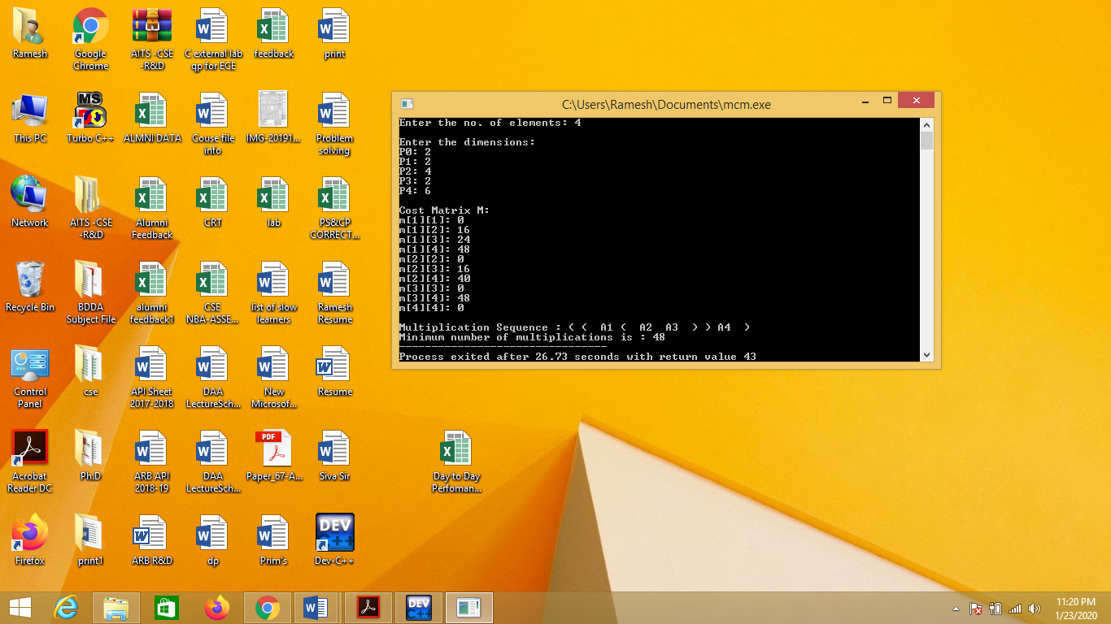

6.7 LAB VIVA QUESTIONS:
1. What is the time complexity of Dijkstra’s algorithm?
2. Define cost matrix.
3. Define directed graph.
4. Define connected graph.

ALL PAIRS SHORTEST PATH PROBLEM

7.1 OBJECTIVE:
Implement All-Pairs Shortest Paths Problem using Floyd's algorithm.
7.2 RESOURCES:
Dev C++
7.3 PROGRAM LOGIC:
Initialize the solution matrix same as the input graph matrix as a first step. Then we update the solution matrix by considering all vertices as an intermediate vertex. The ideas is to one by one pick all vertices and update all shortest paths which include the picked vertex as an intermediate vertex in the shortest path.
When we pick vertex number k as an intermediate vertex, we already have considered vertices
{0, 1, 2, .. k-1} as intermediate vertices.
For every pair (i, j) of source and destination vertices respectively, there are two possible cases.
1)k is not an intermediate vertex in shortest path from i to j. We keep the value of dist[i][j] as it is.
2)k is an intermediate vertex in shortest path from i to j. We update the value of dist[i][j] as
dist[i][k] + dist[k][j].
7.4 PROCEDURE:
1. Create: Open Dev C++, write a program after that save the program with .c extension.
2. Compile: Alt + F9
3. Execute: Ctrl + F10
7.5 SOURCE CODE.
#include<stdio.h>
int min(int,int);
voidfloyds(int p[10][10],int n){
inti,j,k;
for(k=1;k<=n;k++)
for(i=1;i<=n;i++)
for(j=1;j<=n;j++)
if(i==j)
p[i][j]=0;
else
p[i][j]=min(p[i][j],p[i][k]+p[k][j]);
}
int min(inta,int b){
if(a<b)
return(a);
else
return(b);
}
int main(){
int p[10][10],w,n,e,u,v,i,j;
printf("\n Enter the number of vertices:");
scanf("%d",&n);
printf("\n Enter the number of edges:\n");
scanf("%d",&e);
for(i=1;i<=n;i++){
for(j=1;j<=n;j++)
p[i][j]=999;
}
for(i=1;i<=e;i++){
printf("\n Enter the end vertices of edge%d with its weight \n",i);
scanf("%d%d%d",&u,&v,&w);
p[u][v]=w;
}
printf("\n Matrix of input data:\n");
for(i=1;i<=n;i++) {
for(j=1;j<=n;j++)
printf("%d \t",p[i][j]);
printf("\n");
}
floyds(p,n);
printf("\n Transitive closure:\n");
for(i=1;i<=n;i++){
for(j=1;j<=n;j++)
printf("%d \t",p[i][j]);
printf("\n");
}
printf("\n The shortest paths are:\n");
for(i=1;i<=n;i++)
for(j=1;j<=n;j++){
if(i!=j)
printf("\n <%d,%d>=%d",i,j,p[i][j]);
}
}
7.6 INPUT/ OUTPUT
7.7 LAB VIVA QUESTIONS:
1. What is Floyd’s algorithm?
2. What is the time complexity of Floyd’s algorithm?
3. Define Distance Matrix.

OPTIMAL BINARY SEARCH TREE
8.1 OBJECTIVE:
From a given vertex in a weighted connected graph, find shortest paths to other vertices using Dijkstra’s algorithm.
8.2 RESOURCES:
Dev C++
8.3 PROGRAM LOGIC:
1. OBST(i, j) denotes the optimal binary search tree containing the keys ki, ki+1, …, kj;
2. Wi, j denotes the weight matrix for OBST(i, j)
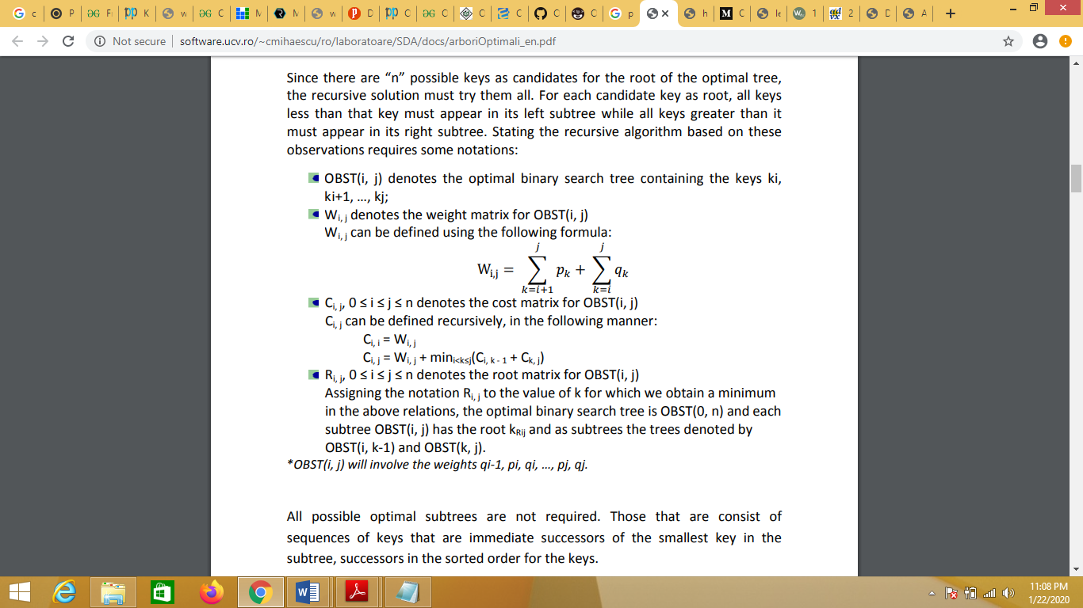
Wi, j can be defined using the following formula:

3. Ci, j, 0 ≤ i ≤ j ≤ n denotes the cost matrix for OBST(i, j)
Ci, j can be defined recursively, in the following manner:
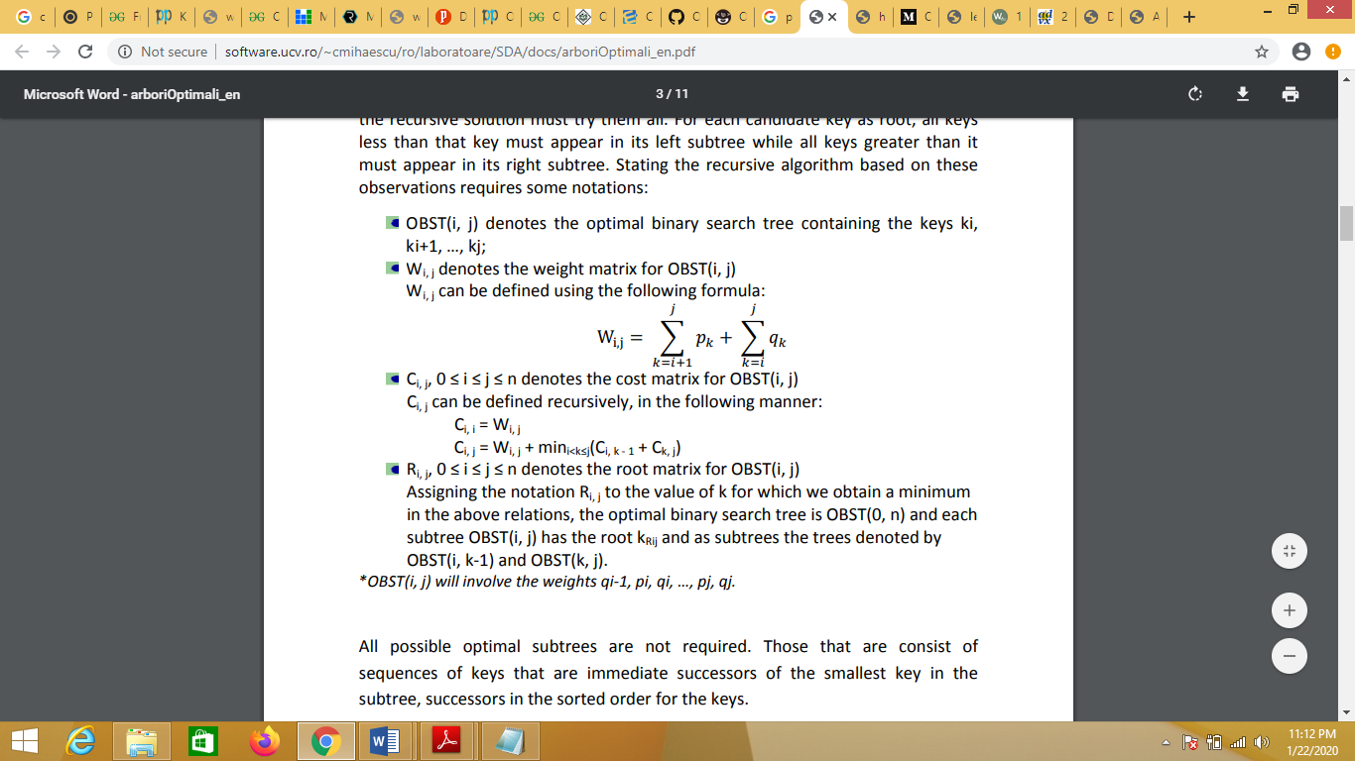

4. Ri, j, 0 ≤ i ≤ j ≤ n denotes the root matrix for OBST(i, j) Assigning the notation Ri, j to the value of k for which we obtain a minimum in the above relations, the optimal binary search tree is OBST(0, n) and each subtree OBST(i, j) has the root kRij and as subtrees the trees denoted by OBST(i, k-1) and OBST(k, j). *OBST(i, j) will involve the weights qi-1, pi, qi, …, pj, qj.
8.4 PROCEDURE:
1. Create: Open Dev C++, write a program after that save the program with .c extension.
2. Compile: F9
3. Execute: F10
8.5 SOURCE CODE:
#include<stdio.h>
#include<conio.h>
#define MAX 10
void main()
{
char ele[MAX][MAX];
int w[MAX][MAX], c[MAX][MAX], r[MAX][MAX], p[MAX], q[MAX];
int temp=0, root, min, min1, n;
int i,j,k,b;
clrscr();
printf("Enter the number of elements:");
scanf("%d",&n);
printf("\n");
for(i=1; i <= n; i++)
{
printf("Enter the Element of %d:",i);
scanf("%d",&p[i]);
}
printf("\n");
for(i=0; i <= n; i++)
{
printf("Enter the Probability of %d:",i);
scanf("%d",&q[i]);
}
printf("W\t\tC\t\tR\n");
for(i=0; i <= n; i++)
{
for(j=0; j <= n; j++)
{
if(i == j)
{
w[i][j] = q[i];
c[i][j] = 0;
r[i][j] = 0;
printf("W[%d][%d]: %d\tC[%d][%d]: %d\tR[%d][%d]: %d\n",i,j,w[i][j],i,j,c[i][j],i,j,r[i][j]);
}
}
}
printf("\n");
for(b=0; b < n; b++)
{
for(i=0,j=b+1; j < n+1 && i < n+1; j++,i++)
{
if(i!=j && i < j)
{
w[i][j] = p[j] + q[j] + w[i][j-1];
min = 30000;
for(k = i+1; k <= j; k++)
{
min1 = c[i][k-1] + c[k][j] + w[i][j];
if(min > min1)
{
min = min1;
temp = k;
}
}
c[i][j] = min;
r[i][j] = temp;
}
printf("W[%d][%d]: %d\tC[%d][%d]: %d\tR[%d][%d]: %d\n",i,j,w[i][j],i,j,c[i][j],i,j,r[i][j]);
}
printf("\n");
}
printf("Minimum cost = %d\n",c[0][n]);
root = r[0][n];
printf("Root = %d \n",root);
getch();
}
8.6 INPUT/ OUTPUT
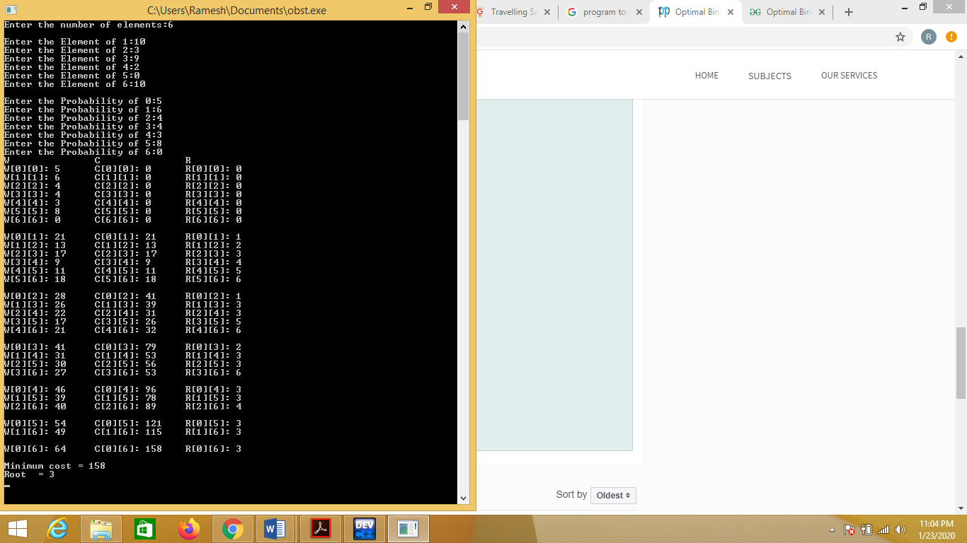
8.7 LAB VIVA QUESTIONS:
1. Define feasible solution of OBST.
2. What is the time complexity for generating OBST?
3. Define optimal solution.
4. Is Optimal Binary Search Tree problem Maximization problem?

N QUEENS PROBLEM
9.1 OBJECTIVE:
Implement N Queen's problem using Back Tracking.
9.2 RESOURCES:
Dev C++
9.3 PROGRAM LOGIC:
1) Start in the leftmost column
2) If all queens are placedreturn true
3) Try all rows in the current column. Do following for every tried row.
a) If the queen can be placed safely in this row then mark this [row, column] as part of the
solution and recursively check if placing queen here leads to a solution.
b) If placing queen in [row, column] leads to a solution then return true.
c) If placing queen doesn't lead to a solution then unmark this [row, column] (Backtrack) and go
to step (a) to try other rows.
3) If all rows have been tried and nothing worked, return false to trigger Backtracking.
9.4 PROCEDURE:
1. Create: Open Dev C++, write a program after that save the program with .c extension.
2. Compile: F9
3. Execute: F10
13.5 SOURCE CODE:
#include<stdio.h>
#include<math.h>
int a[30],count=0;
int place(intpos){
int i;
for(i=1;i<pos;i++){
if((a[i]==a[pos])||((abs(a[i]-a[pos])==abs(i-pos))))
return 0;
}
return 1;
}
voidprint_sol(int n){
inti,j; count++;
printf("\n\nSolution #%d:\n",count);
for(i=1;i<=n;i++){
for(j=1;j<=n;j++){
if(a[i]==j)
printf("Q\t");
else
printf("*\t");
}
printf("\n");
}
}
void queen(int n){
int k=1;
a[k]=0;
while(k!=0){
a[k]=a[k]+1;
while((a[k]<=n)&&!place(k))
a[k]++;
if(a[k]<=n){
if(k==n)
print_sol(n);
else{
k++;
a[k]=0;
}
}
else
k--;
}
}
void main(){
int i,n;
printf("Enter the number of Queens\n");
scanf("%d",&n);
queen(n);
printf("\nTotal solutions=%d",count);
}
9.6 INPUT/ OUTPUT
9.7 LAB VIVA QUESTIONS:
1. Define backtracking.
2. Define live node, dead node.
3. Define implicit and explicit constraints.
4. What is the time complexity of n-queens problem.

0/1 KNAPSCAK USING BRANCH AND BOUND
10.1 OBJECTIVE:
Implement N Queen's problem using Back Tracking.
10.2 RESOURCES:
Dev C++
10.3 PROGRAM LOGIC:
- Sort all items in decreasing order of ratio of value per unit weight so that an upper bound can be computed using Greedy Approach.
- Initialize maximum profit, maxProfit = 0
- Create an empty queue, Q.
- Create a dummy node of decision tree and enqueue it to Q. Profit and weight of dummy node are 0.
- Do following while Q is not empty.
  - Extract an item from Q. Let the extracted item be u.
  - Compute profit of next level node. If the profit is more than maxProfit, then update maxProfit.
  - Compute bound of next level node. If bound is more than maxProfit, then add next level node to Q.
  - Consider the case when next level node is not considered as part of solution and add a node to queue with level as next, but weight and profit without considering next level nodes.
10.4 PROCEDURE:
1. Create: Open Dev C++, write a program after that save the program with .c extension.
2. Compile: F9
3. Execute: F10
10.5 SOURCE CODE:
#include <bits/stdc++.h>
using namespace std;
// Structure for Item which store weight and corresponding value of Item
struct Item
{
float weight;
int value;
};
// Node structure to store information of decision tree
struct Node
{
int level, profit, bound;
float weight;
};
// Comparison function to sort Item according to val/weight ratio
bool cmp(Item a, Item b)
{
double r1 = (double)a.value / a.weight;
double r2 = (double)b.value / b.weight;
return r1 > r2;
}
// Returns bound of profit in subtree rooted with u.
// This function mainly uses Greedy solution to find an upper bound on maximum profit.
int bound(Node u, int n, int W, Item arr[])
{
// if weight overcomes the knapsack capacity, return 0 as expected bound
if (u.weight >= W)
return 0;
// initialize bound on profit by current profit
int profit_bound = u.profit;
int j = u.level + 1;
int totweight = u.weight;
// checking index condition and knapsack capacity condition
while ((j < n) && (totweight + arr[j].weight <= W))
{
totweight += arr[j].weight;
profit_bound += arr[j].value;
j++;
}
// If k is not n, include last item partially for upper bound on profit
if (j < n)
profit_bound += (W - totweight) * arr[j].value /arr[j].weight;
return profit_bound;
}
int knapsack(int W, Item arr[], int n)
{
sort(arr, arr + n, cmp);
queue<Node> Q;
Node u, v;
u.level = -1;
u.profit = u.weight = 0;
Q.push(u);
int maxProfit = 0;
while (!Q.empty())
{
u = Q.front();
Q.pop();
if (u.level == -1)
v.level = 0;
if (u.level == n-1)
continue;
v.level = u.level + 1;
v.weight = u.weight + arr[v.level].weight;
v.profit = u.profit + arr[v.level].value;
if (v.weight <= W && v.profit > maxProfit)
maxProfit = v.profit;
v.bound = bound(v, n, W, arr);
if (v.bound > maxProfit)
Q.push(v);
v.weight = u.weight;
v.profit = u.profit;
v.bound = bound(v, n, W, arr);
if (v.bound > maxProfit)
Q.push(v);
}
return maxProfit;
}
int main()
{
int W = 10; // Weight of knapsack
Item arr[] = {{2, 40}, {3.14, 50}, {1.98, 100}, {5, 95}, {3, 30}};
int n = sizeof(arr) / sizeof(arr[0]);
cout << "Maximum possible profit = "<< knapsack(W, arr, n);
return 0;
}
10.6 INPUT/ OUTPUT
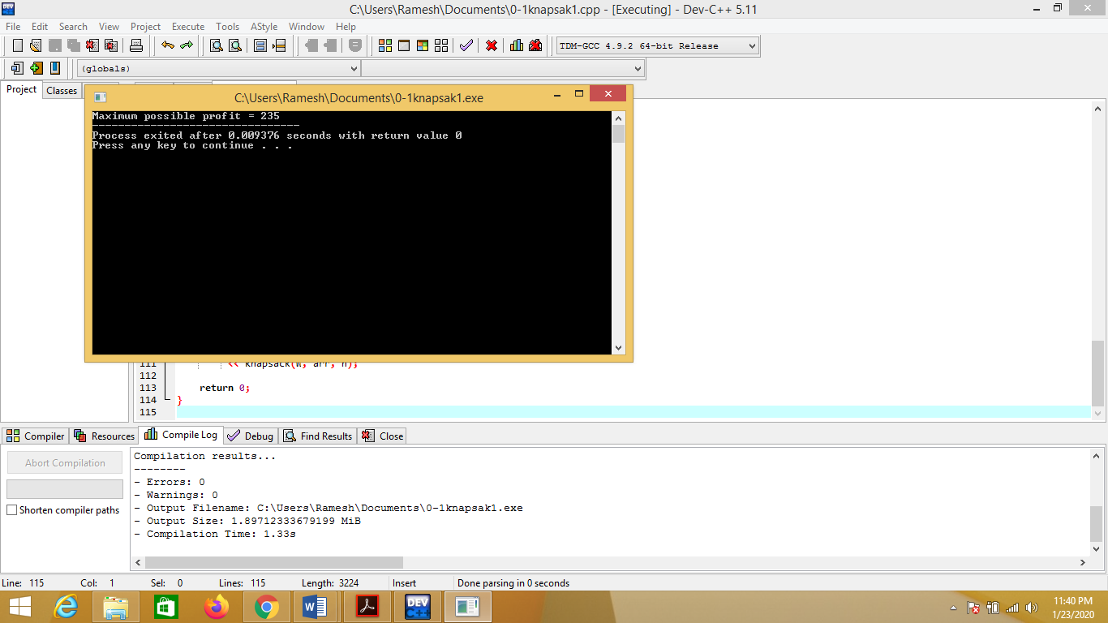

10.7 LAB VIVA QUESTIONS:
1. Branch and bound is a __________
2. Which data structure is used for implementing a LIFO branch and bound strategy?.
3. Which of the following branch and bound strategy leads to depth first search?.
4. Define Bounding function.

TRAVELLING SALES PERSON PROBLEM
11.1 OBJECTIVE:
Find optimal tour of travelling sales person problem using Branch and Bound.
11.2 RESOURCES:
Dev C++
  - PROGRAM LOGIC:
In Branch and Bound method, for current node in tree, we compute a bound on best possible solution that we can get if we down this node. If the bound on best possible solution itself is worse than current best (best computed so far), then we ignore the subtree rooted with the node.
Note that the cost through a node includes two costs.
1) Cost of reaching the node from the root (When we reach a node, we have this cost computed)
2) Cost of reaching an answer from current node to a leaf (We compute a bound on this cost to decide whether to ignore subtree with this node or not).
- In cases of a maximization problem, an upper bound tells us the maximum possible solution if we follow the given node.
- In cases of a minimization problem, a lower bound tells us the minimum possible solution if we follow the given node.
In branch and bound, the challenging part is figuring out a way to compute a bound on best possible solution. Below is an idea used to compute bounds for Traveling salesman problem.
Cost of any tour can be written as below.
Cost of a tour T = (1/2) * &Sum; (Sum of cost of two edges adjacent to u and in the tour T)
11.4 PROCEDURE:
1. Create: Open Dev C++, write a program after that save the program with .c extension.
2. Compile: F9
3. Execute: F10
11.5 SOURCE CODE:
#include <bits/stdc++.h>
using namespace std;
const int N = 4;
// final_path[] stores the final solution ie, the path of the salesman.
int final_path[N+1];
// visited[] keeps track of the already visited nodes in a particular path
bool visited[N];
// Stores the final minimum weight of shortest tour.
int final_res = INT_MAX;
// Function to copy temporary solution to the final solution
void copyToFinal(int curr_path[])
{
for (int i=0; i<N; i++)
final_path[i] = curr_path[i];
final_path[N] = curr_path[0];
}
// Function to find the minimum edge cost having an end at the vertex i
int firstMin(int adj[N][N], int i)
{
int min = INT_MAX;
for (int k=0; k<N; k++)
if (adj[i][k]<min && i != k)
min = adj[i][k];
return min;
}
// function to find the second minimum edge cost having an end at the vertex i
int secondMin(int adj[N][N], int i)
{
int first = INT_MAX, second = INT_MAX;
for (int j=0; j<N; j++)
{
if (i == j)
continue;
if (adj[i][j] <= first)
{
second = first;
first = adj[i][j];
}
else if (adj[i][j] <= second &&
adj[i][j] != first)
second = adj[i][j];
}
return second;
}
// function that takes as arguments:
// curr_bound -> lower bound of the root node
// curr_weight-> stores the weight of the path so far
// level-> current level while moving in the search space tree
// curr_path[] -> where the solution is being stored which would later be copied to final_path[]
void TSPRec(int adj[N][N], int curr_bound, int curr_weight, int level, int curr_path[])
{
// base case is when we have reached level N which means we have covered all the nodes once
if (level==N)
{
// check if there is an edge from last vertex in path back to the first vertex
if (adj[curr_path[level-1]][curr_path[0]] != 0)
{
// curr_res has the total weight of the solution we got
int curr_res = curr_weight + adj[curr_path[level-1]][curr_path[0]];
// Update final result and final path if current result is better.
if (curr_res < final_res)
{
copyToFinal(curr_path);
final_res = curr_res;
}
}
return;
}
// for any other level iterate for all vertices to build the search space tree recursively
for (int i=0; i<N; i++)
{
// Consider next vertex if it is not same (diagonal entry in adjacency matrix and not visited
// already)
if (adj[curr_path[level-1]][i] != 0 &&
visited[i] == false)
{
int temp = curr_bound;
curr_weight += adj[curr_path[level-1]][i];
// different computation of curr_bound for
// level 2 from the other levels
if (level==1)
curr_bound -= ((firstMin(adj, curr_path[level-1]) +
firstMin(adj, i))/2);
else
curr_bound -= ((secondMin(adj, curr_path[level-1]) +
firstMin(adj, i))/2);
// curr_bound + curr_weight is the actual lower bound for the node that we have arrived
//on If current lower bound < final_res, we need to explore the node further
if (curr_bound + curr_weight < final_res)
{
curr_path[level] = i;
visited[i] = true;
// call TSPRec for the next level
TSPRec(adj, curr_bound, curr_weight, level+1, curr_path);
}
// Else we have to prune the node by resetting all changes to curr_weight and curr_bound
curr_weight -= adj[curr_path[level-1]][i];
curr_bound = temp;
// Also reset the visited array
memset(visited, false, sizeof(visited));
for (int j=0; j<=level-1; j++)
visited[curr_path[j]] = true;
}
}
}
// This function sets up final_path[]
void TSP(int adj[N][N])
{
int curr_path[N+1];
// Calculate initial lower bound for the root node
// using the formula 1/2 * (sum of first min + second min) for all edges.
// Also initialize the curr_path and visited array
int curr_bound = 0;
memset(curr_path, -1, sizeof(curr_path));
memset(visited, 0, sizeof(curr_path));
// Compute initial bound
for (int i=0; i<N; i++)
curr_bound += (firstMin(adj, i) +
secondMin(adj, i));
// Rounding off the lower bound to an integer
curr_bound = (curr_bound&1)? curr_bound/2 + 1 :
curr_bound/2;
// We start at vertex 1 so the first vertex in curr_path[] is 0
visited[0] = true;
curr_path[0] = 0;
TSPRec(adj, curr_bound, 0, 1, curr_path);
}
int main()
{
//Adjacency matrix for the given graph
int adj[N][N] = { {0, 10, 15, 20},
{10, 0, 35, 25},
{15, 35, 0, 30},
{20, 25, 30, 0}
};
TSP(adj);
printf("Minimum cost : %d\n", final_res);
printf("Path Taken : ");
for (int i=0; i<=N; i++)
printf("%d ", final_path[i]);
return 0;
}

11.6 INPUT/ OUTPUT
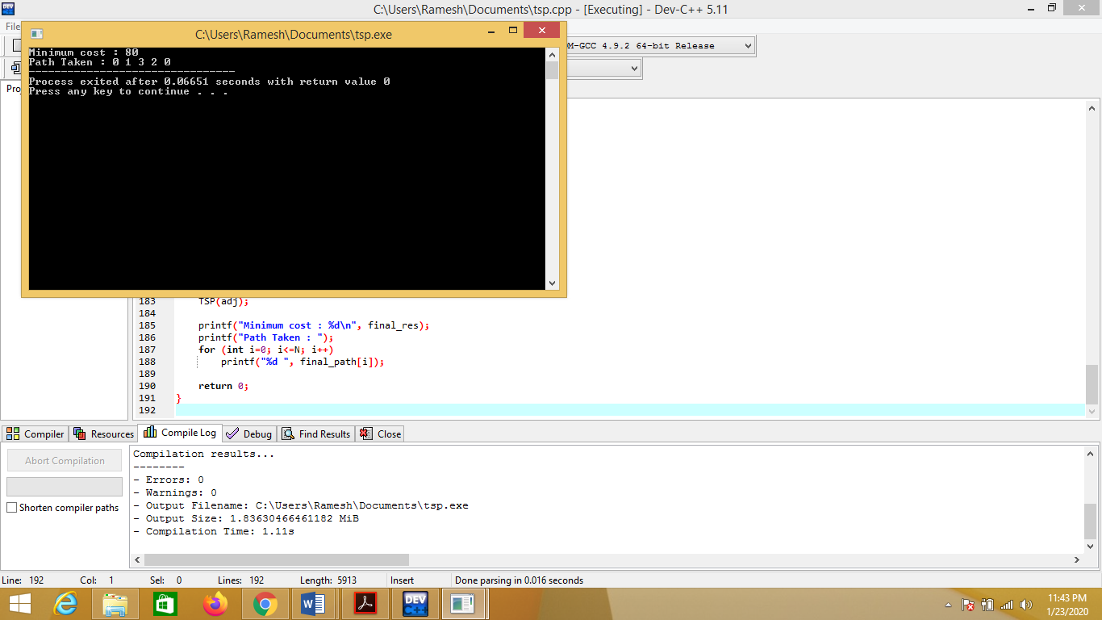
11.7 LAB VIVA QUESTIONS:
1. Both LIFO branch and bound strategy and backtracking leads to depth first search.
2. Define reduced cost matrix.
3. What is state space tree?
4. E-node means.

